Order Of Lenten Service

Opening Hymn: TLH 140

Reading: Lent I

The History of the Passion of our Lord

Sermon Hymn: TLH 142

Sermon Text: Daniel 3:1-7

The Golden Image

Prayer

Holy Communion

The Lord's Prayer

The Blessing

Closing Hymn: TLH 147

* * * * * * * * * * * * *

Bible Study: Lambs: Badger
Sheep: Romans 9:1-5

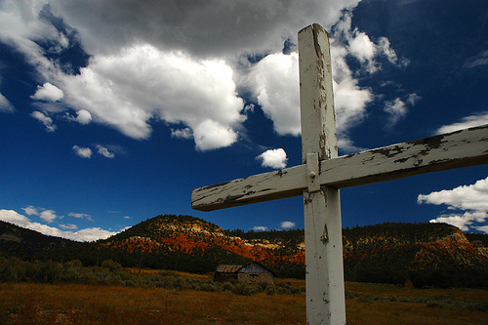

Cross Of Life

Water
Of
Life
11 February 2018

W A T E R O F L I F E

Independent Christian Church—Conservative Lutheran Doctrine

Worship Service: 9:30 a.m. Bible Study: 10:45 a.m.

Larry Cooper, Pastor E-Mail address:
111 N. Ridge Road lcooper@wateroflife.cc
Coon Valley, WI 54623 Web Site:
Phone: (608) 452-2105 www.wateroflife.cc

* * * * * * * * * * * * * * * * * * * * * * * * * * *

Sermon Text: Daniel 3:1-7

The Golden Image

* * * * * * * * * * * * * * * * * * * * * * * * * * *

Daniel 3:1 Nebuchadnezzar the king made an image of gold, whose height was threescore cubits, and the breadth thereof six cubits: he set it up in the plain of Dura, in the province of Babylon.
:2 Then Nebuchadnezzar the king sent to gather together the princes, the governors, and the captains, the judges, the treasurers, the counsellors, the sheriffs, and all the rulers of the provinces, to come to the dedication of the image which Nebuchadnezzar the king had set up.
:3 Then the princes, the governors, and captains, the judges, the treasurers, the counsellors, the sheriffs, and all the rulers of the provinces, were gathered together unto the dedication of the image that Nebuchadnezzar the king had set up; and they stood before the image that Nebuchadnezzar had set up.
:4 Then an herald cried aloud, To you it is commanded, O people, nations, and languages,
:5 That at what time ye hear the sound of the cornet, flute, harp, sackbut, psaltery, dulcimer, and all kinds of musick, ye fall down and worship the golden image that Nebuchadnezzar the king hath set up:
:6 And whoso falleth not down and worshippeth shall the same hour be cast into the midst of a burning fiery furnace.
:7 Therefore at that time, when all the people heard the sound of the cornet, flute, harp, sackbut, psaltery, and all kinds of musick, all the people, the nations, and the languages, fell down and worshipped the golden image that Nebuchadnezzar the king had set up.

Related Passage—Esther 3:1-6

1 After these things did king Ahasuerus promote Haman the son of Hammedatha the Agagite, and advanced him, and set his seat above all the princes that were with him.
2 And all the king's servants, that were in the king's gate, bowed, and reverenced Haman: for the king had so commanded concerning him. But Mordecai bowed not, nor did him reverence.
3 Then the king's servants, which were in the king's gate, said unto Mordecai, Why transgressest thou the king's commandment?
4 Now it came to pass, when they spake daily unto him, and he hearkened not unto them, that they told Haman, to see whether Mordecai's matters would stand: for he had told them that he was a Jew.
5 And when Haman saw that Mordecai bowed not, nor did him reverence, then was Haman full of wrath.
6 And he thought scorn to lay hands on Mordecai alone; for they had shewed him the people of Mordecai: wherefore Haman sought to destroy all the Jews that were throughout the whole kingdom of Ahasuerus, even the people of Mordecai.

